UNIVERSITY

PERFORMACE

MANAGEMENT / RANKING

MODEL

- Jinal Mamaniya: 001095667

- Tarun Balwani: 001561792

- Sneha Methwani: 002190327

# Introduction

Performance measurement of any university is measured by many factors and one of the core factors is quality of education provided by university and how these taught courses will eventually lead the student to get their dream jobs. A performance measurement solution is created using software engineering techniques that enables universities to measure the quality of the education they deliver to their students. The feedback from the alumni and current students who are either on co-op/parttime are taken into account to determine the factors like faculty and courses in the educational system that contributed to their growth over a 5-year span.

# Proposed Solution

Our important focus is to build a performance measurement solution to measure the quality of education they deliver to the students, so the current and future students will have a better idea about selecting courses by analyzing their interest and relevant university ranking.

This is not only limited to the students but more to the Admin as they can open the dashboard and see the count or list of courses students have opted and which led to them on co-op/part-time. Also, we have included the Feedback form for the students which will provide the ranking of the courses they have enrolled and how much it is/was useful.

The dashboard will include view colleges, departments, courses, classes, view student enrollment details, view student employment details and last but not the least the feedback form to capture the courses helped to improve skills and knowledge gain. Hence, using this module the admin can evaluate the performance that will be helpful for Admin and Students too.

# Model Assumptions:

* The factors which affect the rating of the course have been emphasized upon directly to the ranking of the university. Any undeclared condition and/or parameters would be a limitation to the scope of the university course’s ranking model and its evaluation.
* The amalgamation of roles and responsibilities of namely Students, Faculty, Courses, Enrollments and Student Feedback - the factors affecting the ranking of the university model and its course evaluation.

# ENTITY:

* + **User:** It holds the list of all the User.
  + **Role:** User can be **Student**, **Faculty** and **Admin**
  + **College:** List of colleges under the university
  + **Departments:** one college can have multiple Departments
  + **Course:** It holds all the courses offered in the university
  + **Classes:** one course can have multiple classes which taught by faculties
  + **Enrollments/ Registration:** Student enrolled for various courses
  + **Employment:** List of students who secured co-op/part-time employment
* **Course Feedback:** It takes into account all the feedback from the particular courses and which is given by the Current student and student alumina who have secured co-op and internship
* **Skills:** Student who are/were in co-op and part-time can fill up the form of expected skills in the industry
* **Student:** Holds information of all the persons, name, NUID, and courses allocated to them
* **Admin**: View information about Student, Faculty, Courses, Feedback and Enrollment information etc.
* **Student:** Holds information of all the persons, name, NUID, and courses allocated to them
* **Faculty:** Holds information of all the persons, faculty assignments, name, id, and courses allocated to them

# CLASS DIAGRAM

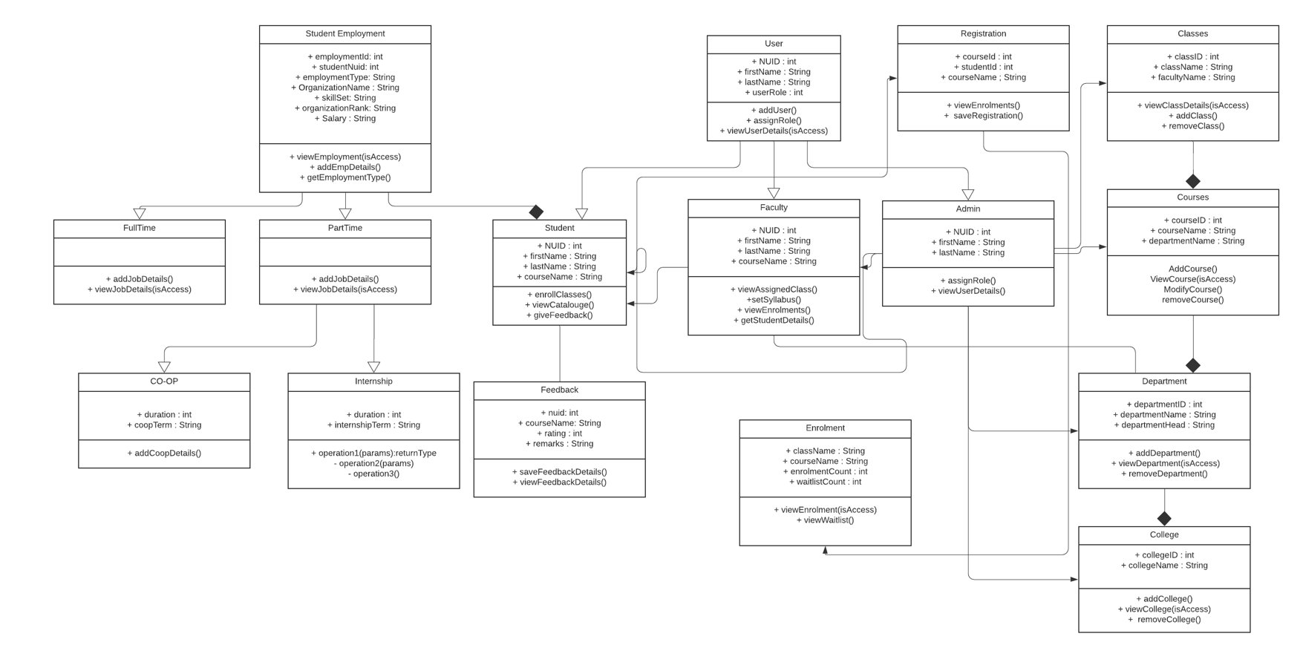

# SEQUENCE DIAGRAM

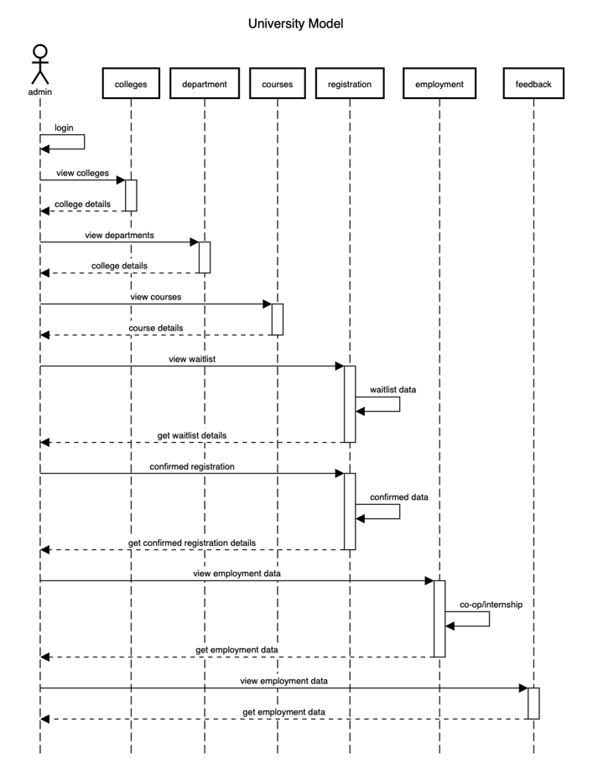

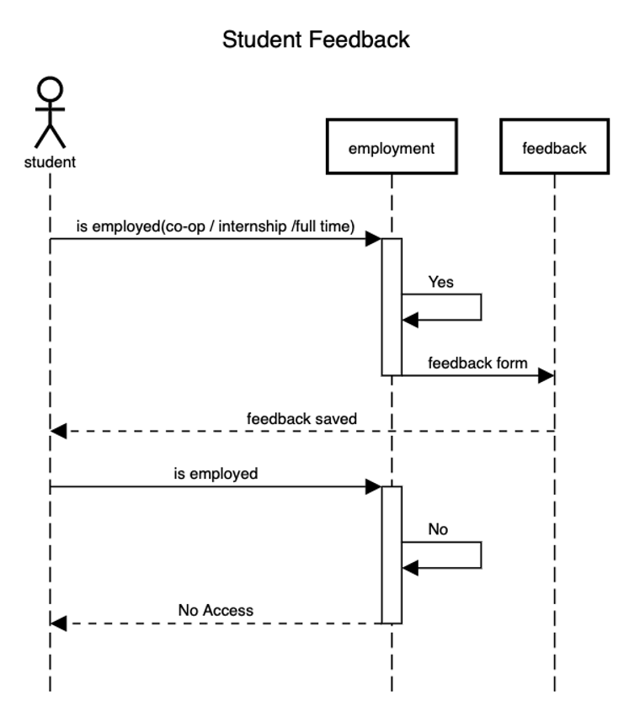

# DASHBOARDS

# 

# 

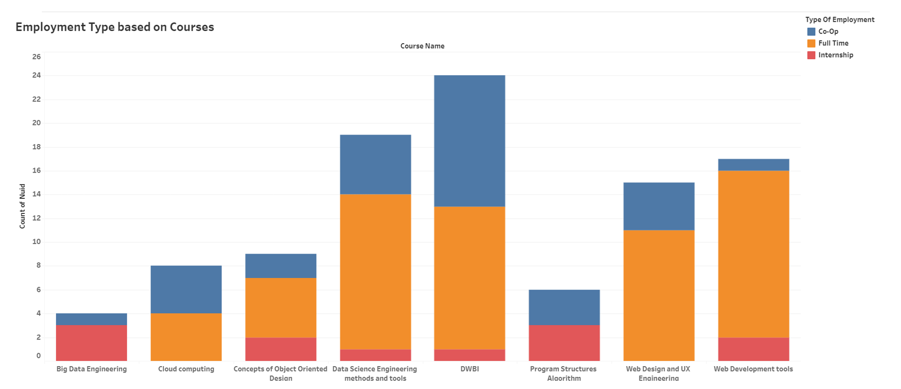

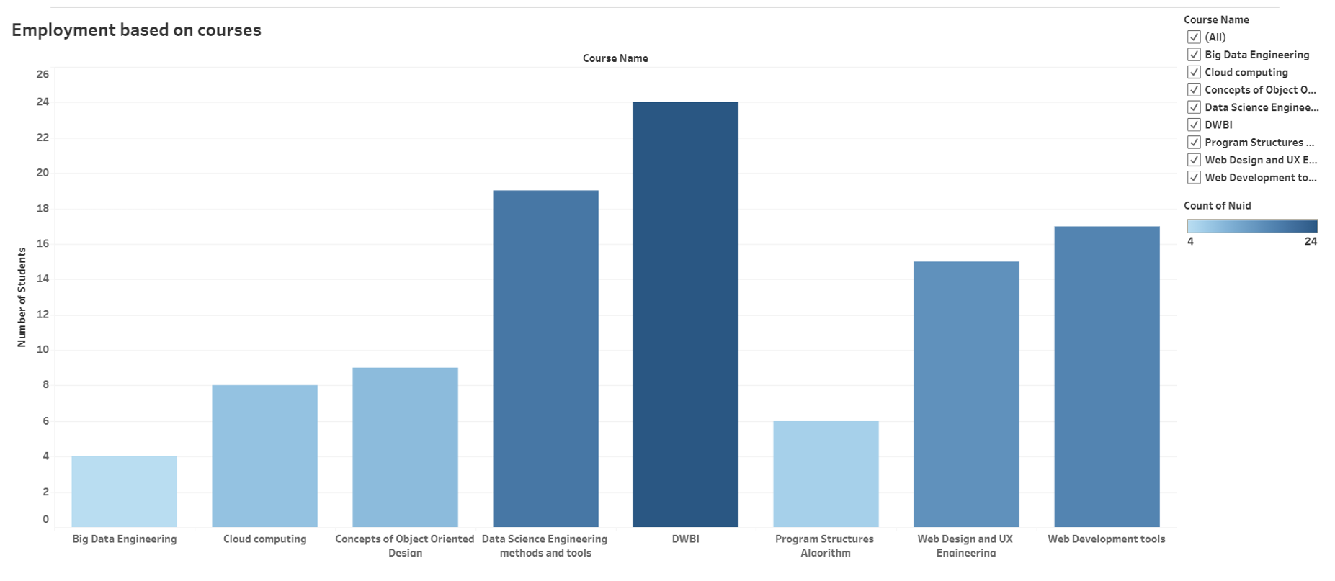

# USER INTERFACES

# 

# 

# 

# 

# 

# 

# 

# 

# 

# 

